CONGRESSIONAL LUNCH BRIEFINNG

Securing a Stronger America Through Increased U.S. Production of Healthful, Sustainable, and Affordable Seafood

March 14,2018 12:00 PM
902 Hart Senate Office Building

AGENDA

12:00 PM Welcome
U.S. Senator Roger Wicker (R-MS) INVITED

12:05 PM Introductions
Moderator: Kathryn Unger
Country Director, North America
Cargill Aqua Nutrition

12:10 PM Aquaculture Overview and Observations from the Environmental Community
Jennifer Kemmerly
Director of Global Fisheries and Aquaculture
Monterey Bay Aquarium

12:20 PM Marine Aquaculture: An American Opportunity
Tony Dal Ponte
Deputy General Counsel
Pacific Seafood

12:30 PM Marine Aquaculture at Work
Todd Madsen
CEO
Blue Ocean Mariculture

12:40 PM Observations from the Investment Community
Max Holtzman
Principal
Pontos Aqua Advisory

12:50 AM Question and Answer

1:00 PM ADJOURN

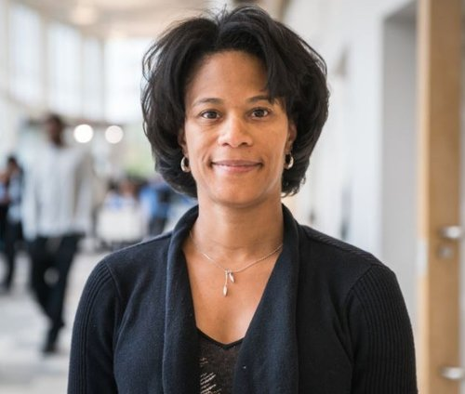
Kathryn Unger- is a Country Director for Cargill’s Aqua Nutrition (CQN) group. She joined Cargill in 2014 in their growing aquaculture business. In her current role, she is responsible for serving aquaculture customers and employees in North America. Prior to joining Cargill, Kathryn worked for Cummins, Inc. for nearly 10 years, leading the Rail and Defense Engine Businesses, globally. Kathryn was also a tax consultant at PricewaterhouseCoopers in Houston, Texas, and a teacher in both North Carolina and in Colombia, South America. undergraduate degree in education and a master’s degree in accounting from the University of North Carolina at Chapel Hill and an MBA from Stanford University.

.
Tony Dal Ponte is the deputy general counsel at Pacific Seafood. For the past four years he has been recognized as a Super Lawyers "Rising Star." Tony earned a B.A. in Economics from the University of Oregon and a J.D., cum laude, from the University of Notre Dame. He currently serves as an Adjunct Professor of Political Science at the University of Portland. Tony is actively involved in activities around the state. He is a founding member and current board member of Emerging Leaders for Oregon and was a co-director of Freedom Oregon. He has also served as legal counsel and adviser to candidates for both state and federal office.

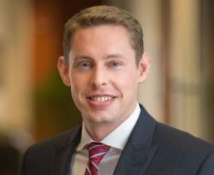

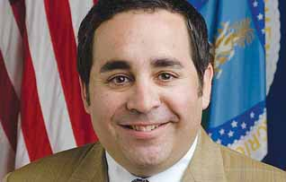
Max Holtzman- Principal at Pontos Aqua Advisory and Vice Chairman of Capitol Peak Asset Management. Senior Advisor to the United States Secretary of Agriculture, 6 years. USDA Acting Deputy Under Secretary for Farm and Foreign Agricultural Services. USDA Acting Deputy Under Secretary of Marketing and Regulatory Programs. U.S./China Joint Committee on Commerce and Trade, 4-year delegate. Board member of K Street Capital, the Arcadia Center for Sustainable Food and Agriculture. Founding Chairman of Adopt-A-Classroom. University of Florida, Institute of Food and Agricultural Sciences “IFAS” and University of Miami School of Law.

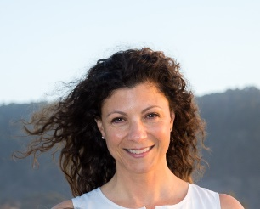
Jennifer Kemmerly- directs Monterey Bay Aquarium’s activities in support of sustainable fisheries and aquaculture on a global scale, working with a range of stakeholders to drive improvements in environmental performance, social responsibility and management. This includes the respected Seafood Watch program, which engages and empowers North American consumers and businesses to support ocean-friendly fisheries and aquaculture through their purchasing decisions.

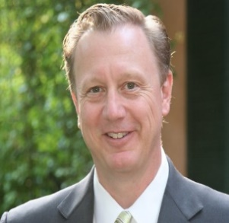
Todd Madsen - is the President of Blue Ocean Mariculture. Blue Ocean is the leader in sustainable open ocean aquaculture in the U.S., producing Hawaiian Kanpachi (Seriola rivoliana) for premium fresh seafood markets and discerning chefs. Previously, Mr. Madsen served as President of OceanSpar, Inc., a maker of submersible net pen equipment for open ocean fish farms around the world. Mr. Madsen holds an MBA in Finance and Economics from the University of Chicago and a BS in Computer Science from Illinois State University.

